Hadoop Cluster Installation - Automated

1. Setup number of nodes for Hadoop installation.
2. Note IPADDRESS and HOSTNAME for above nodes.
3. For cloud environment make sure you have required “Firewall” rules in place
4. **Note**(1. Set 2 way communication betn all nodes  
    2. OPen all trafic from your desktop/laptop IP to both machines  
    3. Access to repo server for both machines to download packages)
5. Login to Ambari Server[Master] node via ssh.
6. Execute below command –  
   [Note: Make sure you have “git” package installed on the system]

#yum install git –y   
#cd /opt/  
#git clone <https://github.com/shimpisagar/single_multinode_autodeploy.git>

1. You will see below filesystem structure after executing above step –  
     
   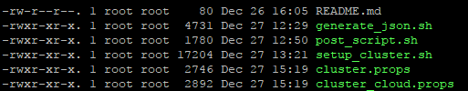
2. Below are the respective files descriptions –  
     
   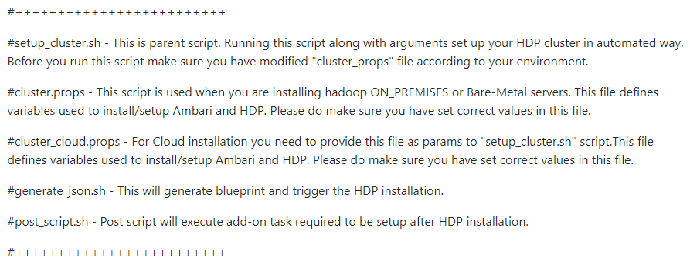
3. Modify “cluster.props” or “cluster_cloud.props” [depending upon your environment] and make sure you set all variable values properly before you run the script.

Note:- cluster.props for bare metal machines and cluster_cloud.props for cloud.

1. Run the script -  
     
   #./setup_cluster.sh cluster.props #[ For on-premises on bare-metal nodes ]  
   #./setup_cluster.sh cluster_cloud.props #[ For Cloud environment ]

#./[post_script.sh](https://github.com/shimpisagar/single_multinode_autodeploy/blob/master/post_script.sh) cluster_cloud.props